**ASSIGNMENT-4**

|  |  |
| --- | --- |
| **Assignment Date** | 05 November 2022 |
| **Student Name** | SWEATHA.V |
| **Student Register Number** | 111419106103 |
| **Maximum Marks** | 2 Marks |

**Question 1:**

Pull an Image from docker hub and run it in docker playground.

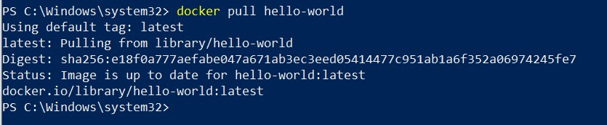

**Question 2:**

Create a docker file for the job portal application and deploy it in Docker Desktop Application

FROM

helloworld:lates t WORKDIR

~/Desktop/ ADD .

helloworld/

WORKDIR

~/Desktop/htmlfile

RUN pip install -r requirements RUN chmod +x app.sh

CMD ["/bi n/sh","app.sh"]

**Question 3:**

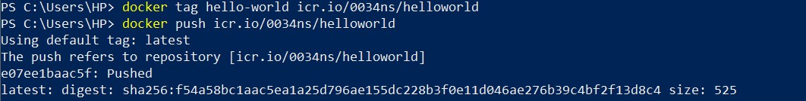

Create an IBM container registry and deploy helloworld app or Job portal app.

**Question 4:**

Create a Kubernetes cluster in IBM cloud and deploy helloworld image or job portal image and also expose the same app to run in node port.

